PROJECT DEMONSTRATION PHASE
Introduction
Project Title:
AI Blog Nest API – An Intelligent Backend for Blog Operations
Team ID : SWTID-2026-4636
Team Leader : SAI TEJA SHRI P
Team member :
SAI TEJA SHRI P
YAMINISREE P
HARSHITHA K
ISHWARYALAKSHMI S
Blog Nest is an AI-powered blogging backend application developed using Node.js and Express.js. The project provides APIs for user authentication, profile management, blog management, and AI-based content generation and summarization.
The project was developed and tested using Visual Studio Code, Postman, MongoDB, and Google Gemini API.
The main purpose of this demonstration is to show how the backend works, how the APIs are tested, how data is stored in MongoDB, and how the AI features are integrated into the application.
Technologies Used
The following technologies and tools were used in the project:
- Node.js – Backend runtime environment
- Express.js – Backend framework
- MongoDB – Database
- Mongoose – MongoDB connection and data modeling
- JWT – User authentication
- bcryptjs – Password hashing
- Google Gemini API – AI content generation and summarization
- Postman – API testing
- Visual Studio Code – Development environment
- Nodemon – Automatic server restarting during development
Project Development Environment
The project was developed using Visual Studio Code.
The project contains different folders and files for handling routes, controllers, middleware, models, configuration, and server operations.
This structure helps to keep the backend organized and makes it easier to manage different functionalities separately.
[VS Code Project Folder Structure]
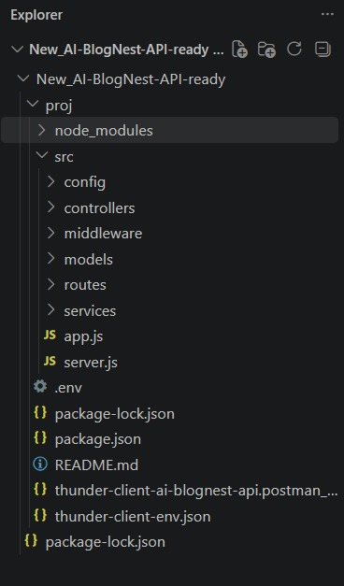
Backend Server Initialization
The backend application is started using Node.js and Nodemon.
After starting the application, the server runs on port 5000.
The environment configuration is loaded and the application establishes a connection with the MongoDB database.
[ VS Code Terminal Showing Server Running]
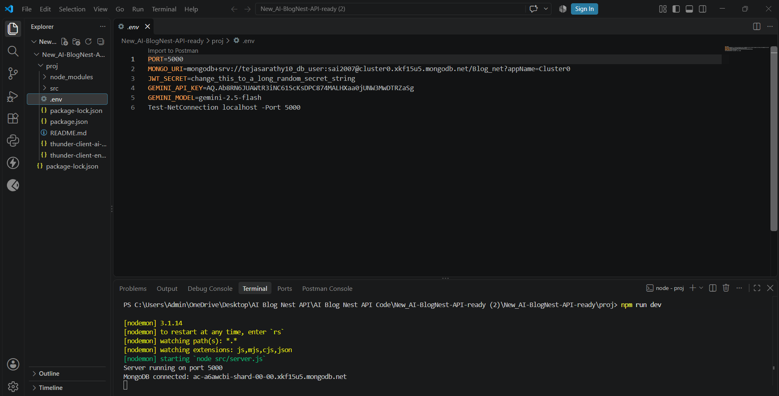
MongoDB Database Connection
MongoDB is used as the database for Blog Nest.
The application uses Mongoose to connect the Node.js backend with MongoDB.
MongoDB stores information such as:
- User details
- Authentication-related data
- Blog information
- Blog title and category
- Blog content
- Created and updated timestamps
The database connection allows the application to store and retrieve information whenever an API request is made.
[ MongoDB Database/Collection Screenshot]
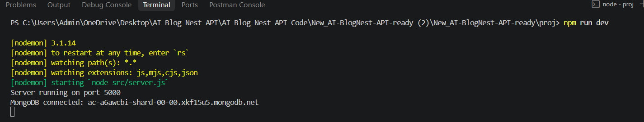
API Testing Using Postman
Postman is used to test and demonstrate the different REST API endpoints of Blog Nest.
The API requests are sent to the local backend server running on port 5000.
The major API operations demonstrated are:
- User registration
- User login
- Blog creation
- Fetch blog
- AI blog generation
- AI blog summarization
User Registration
The first step is to register a new user.
The registration API accepts basic user information such as:
- Name
- Email
- Password
The password is securely processed before being stored.
After successful registration, the API returns a successful response.
[Postman Registration Request and Response]
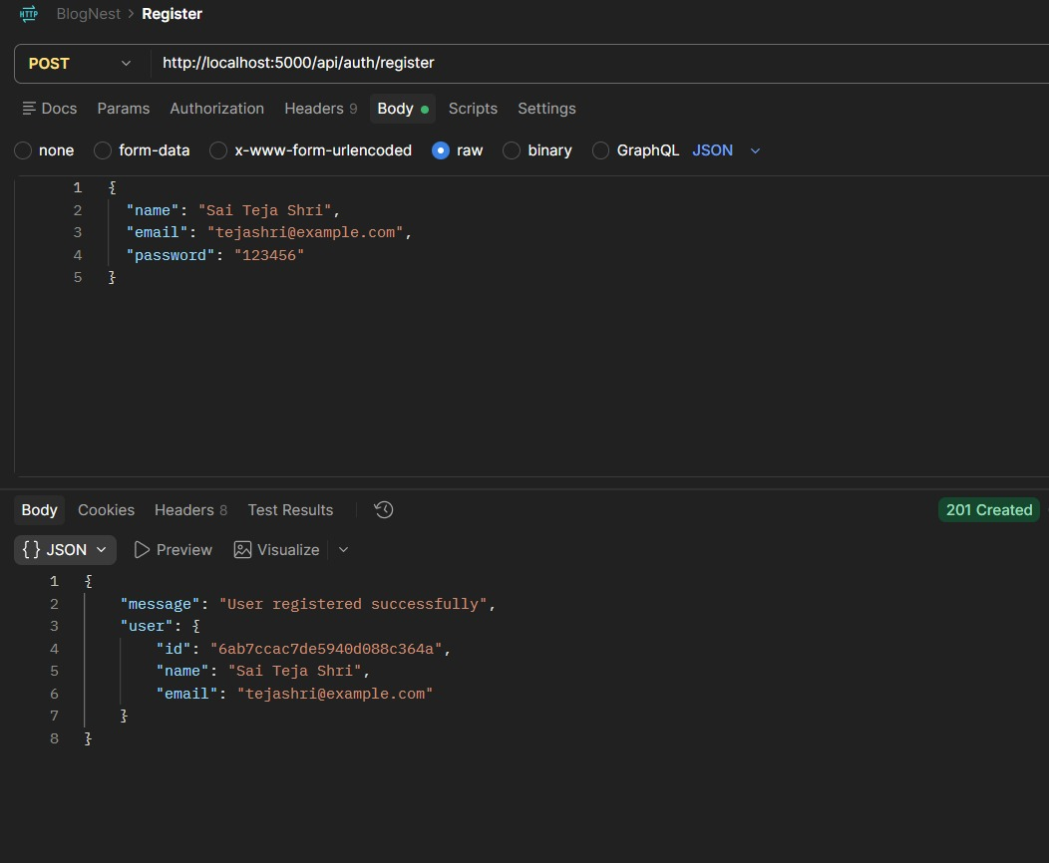
User Login
After registration, the user can log in using the registered email and password.
When the login is successful, the backend generates a JWT authentication token.
This token is required to access protected APIs.
[Postman Login Request and JWT Response]
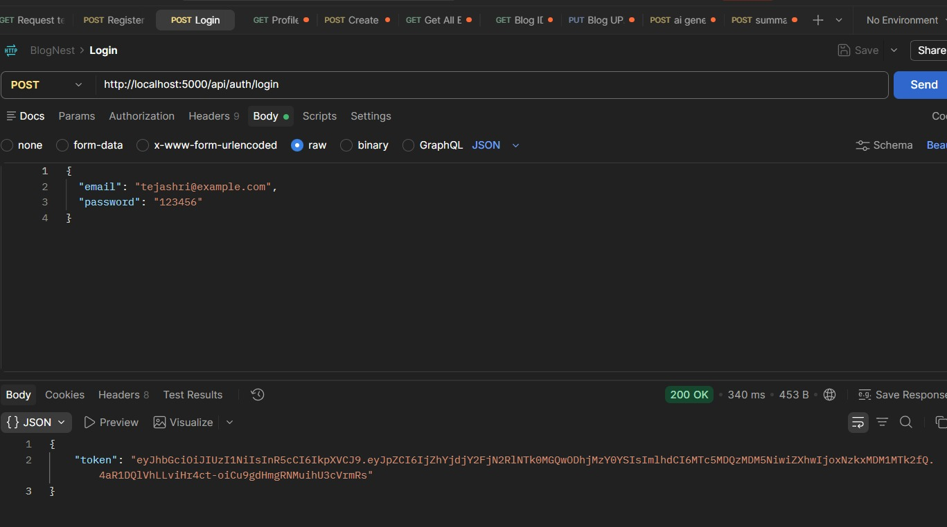
Creating a Blog
A new blog can be created by sending a request containing details such as:
- Blog title
- Category
- Blog content
The request is authenticated using the JWT token.
After successful creation, the blog is stored in MongoDB and the API returns the created blog details.
[ Create Blog API in Postman]
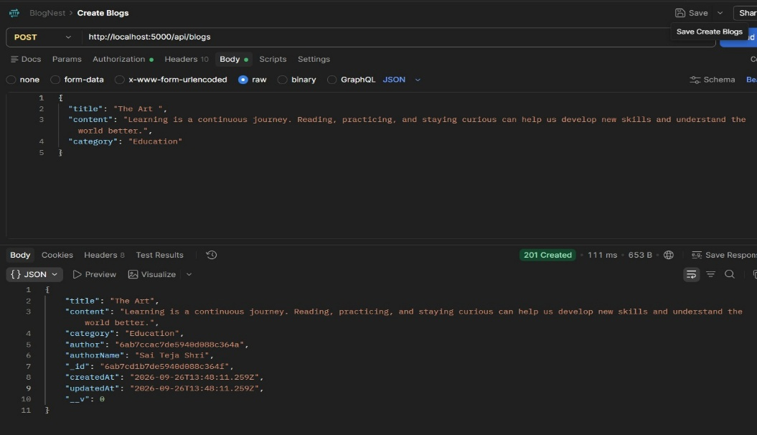
Fetch Blogs
The application provides an API to retrieve the available blogs.
The API fetches the stored blog records from MongoDB and displays them in the response.
[Fetch Blogs API Response]
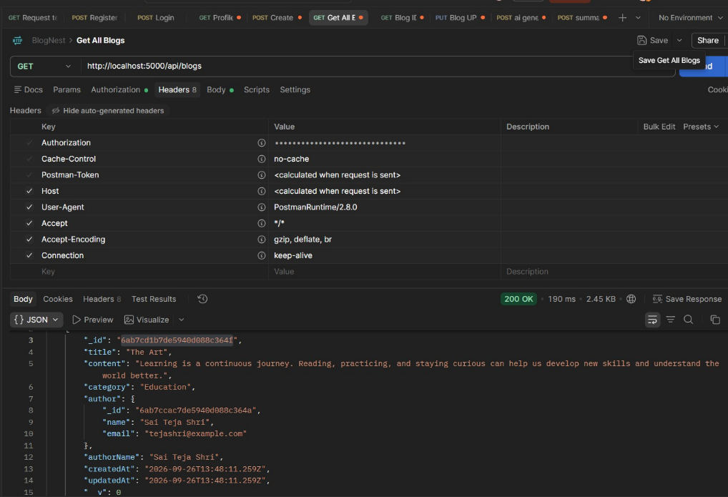
AI-Blog Generation
One of the main features of Blog Nest is AI-powered content generation.
The project integrates Google Gemini to generate blog content.
The user provides information such as:
- Topic
- Category
The backend sends this information to Gemini and receives generated blog content.
This generated content can then be used as a starting point for creating a blog.
[Generate Blog API Request]
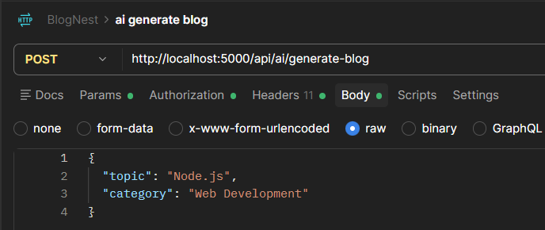
[ Generated Blog Response]
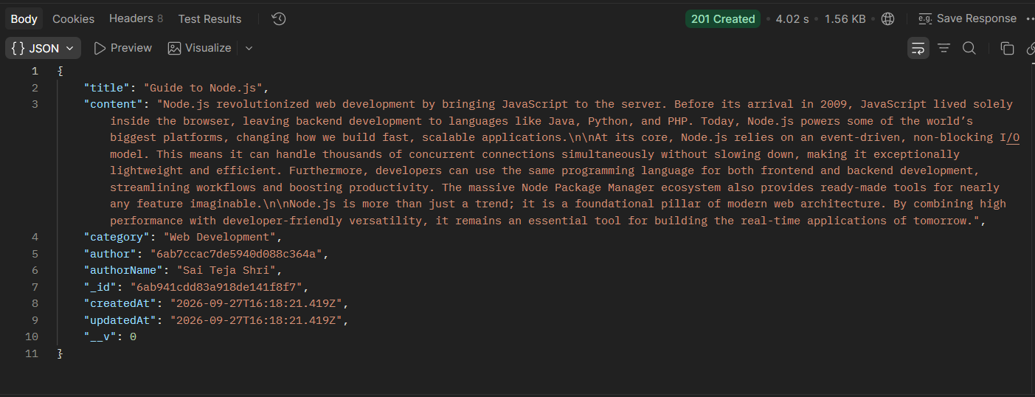
[AI-Blog Generation]
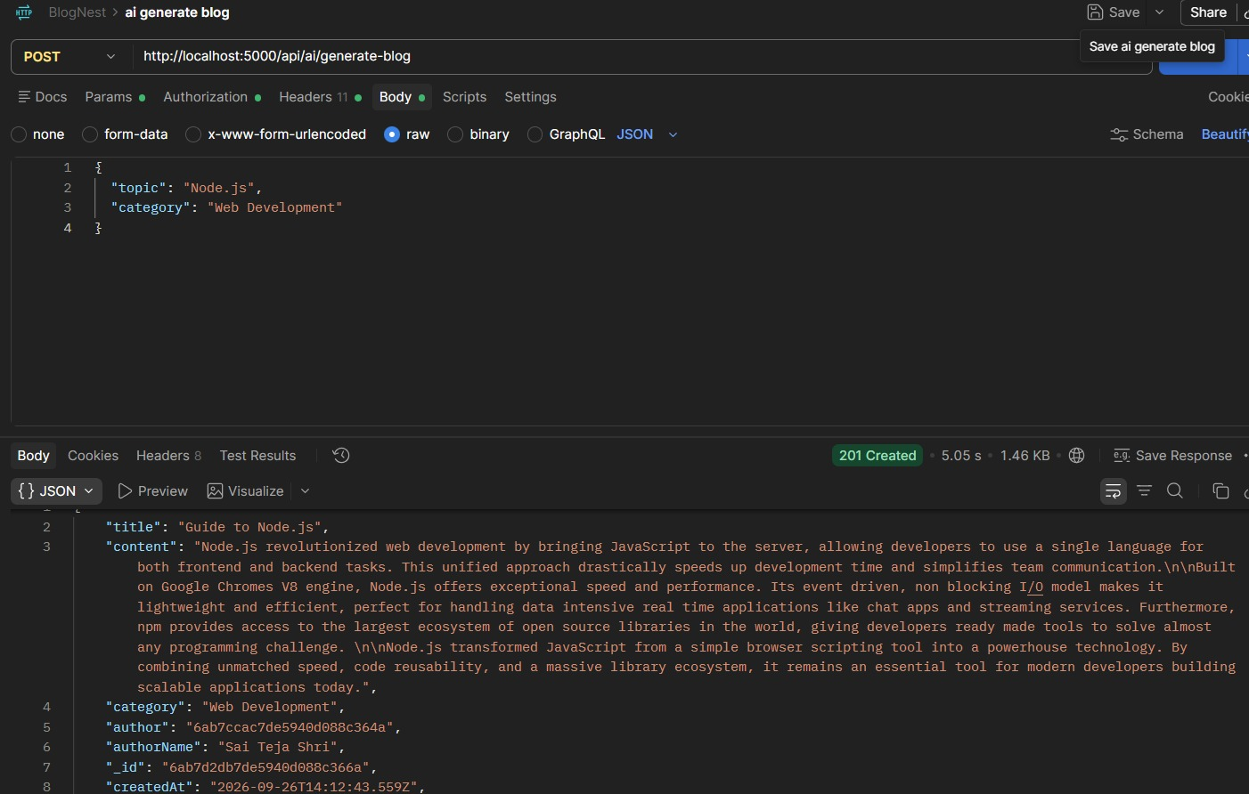
AI-Powered Blog Summarization
Blog Nest also provides an AI summarization feature.
The summarization API accepts blog content and processes it using Google Gemini.
The AI generates a shorter and easier-to-understand summary of the provided content.
This feature can be useful when users want to quickly understand long blog content.
[ Summarization API Request and Response]
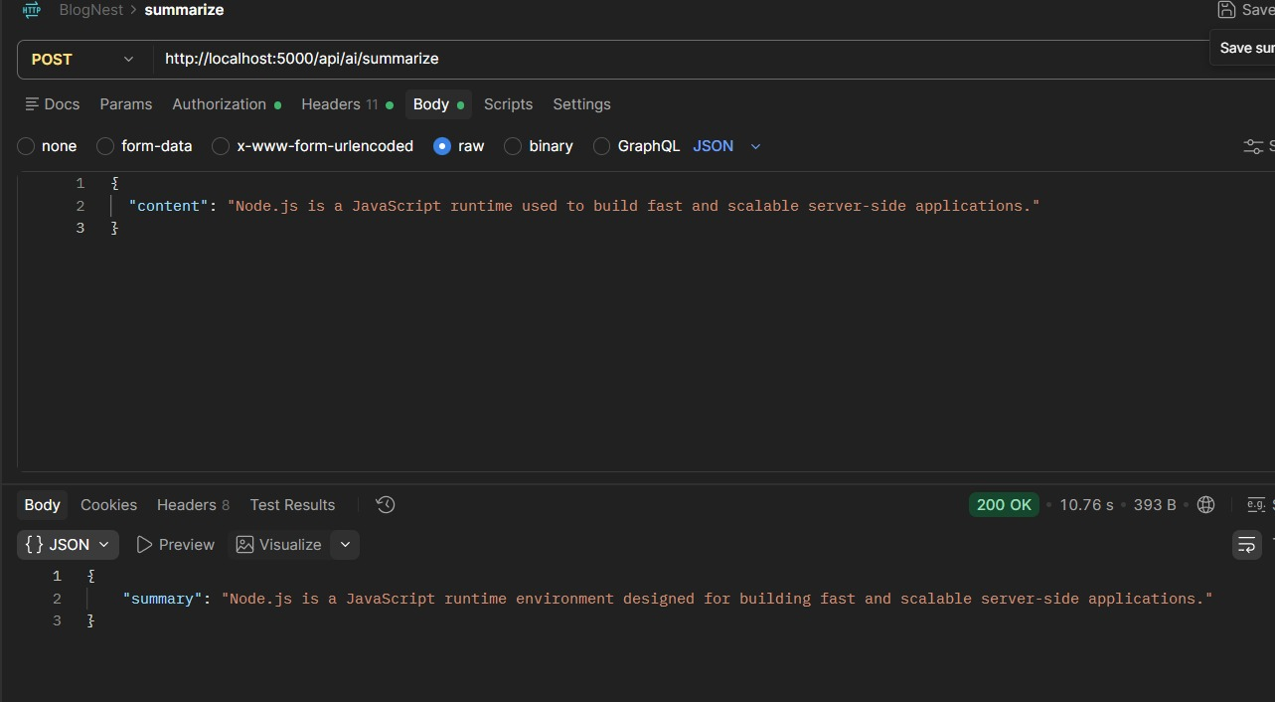
Complete Project Demonstration Flow
The complete demonstration of Blog Nest follows this flow:
Start Server → Connect MongoDB → Register User → Login → Generate JWT Token → Access Protected APIs → Create Blog → Fetch Blog → Generate AI Content → Summarize Blog
This demonstrates how the different components of the application work together.
Demonstration Summary
The Project Demonstration Phase shows the working functionality of Blog Nest.
The application successfully demonstrates backend development using Node.js and Express.js, database management using MongoDB, API testing using Postman, secure user authentication using JWT, and AI-based content generation and summarization using Google Gemini.
The demonstration provides a complete view of how the different components work together to create an AI-powered blogging backend application.
Demo Video : Demo Videos
GitHub link : GitHub

